Agribot

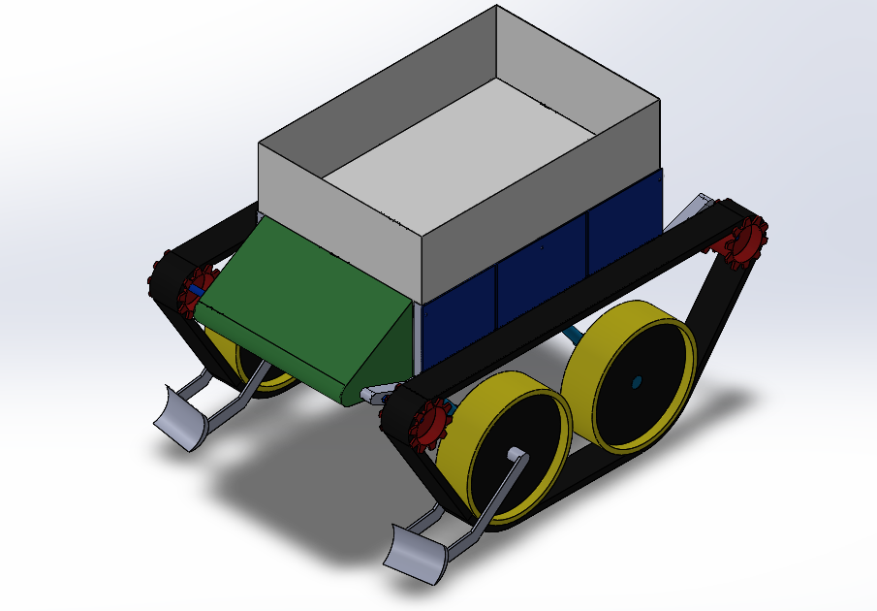
Front side Isometric View
Specifications:
Weight: 150 Kg approx
Volume: 0.136 cubic m.
Bounding Box: 1.8*1.25*1.2 (All in meters)
Materials: Aluminum alloy 6061, abs plastic, PVC foam, Rubber and Carbon fibre rods.
Max speed: 0.3 m/s

Overview:
A robotic vehicle designed for the purpose of carrying loads like coconuts in wet fields with a maximum payload of 80 Kg. It runs on caterpillar motion to avoid the difficulties a conventional rubber tyre may cause in wet fields, it also has a hydraulic mechanism to unload the load to prevent human labour. It is fully electrical, self-driving, lightweight and cost-effective so that most farmers can afford it. It is enabled with all the required sensors and cameras for the perfect functioning of the vehicle. It has a battery capacity that can run the robot for close to 6hrs, then after you need to recharge the battery and it will be good to go. It is suitable for any climatic conditions(Water resistant).
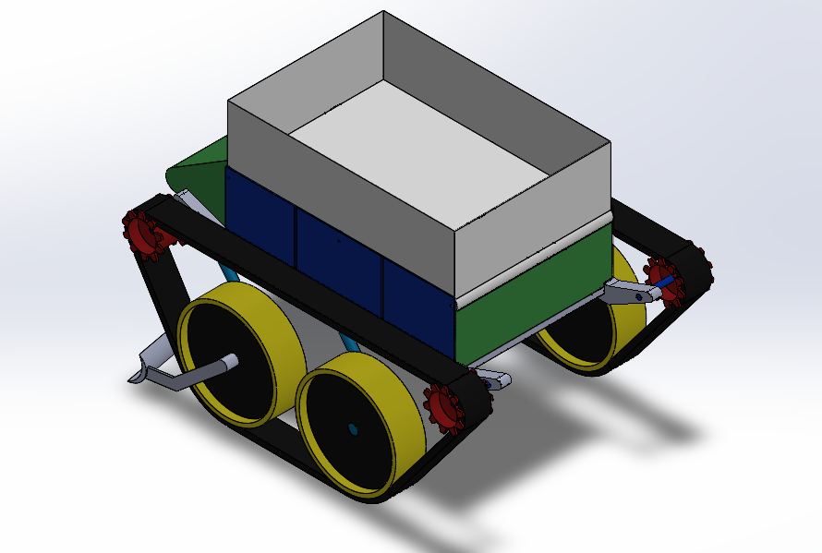
Rear side isometric view

The vehicle is run by four dc motors which power the red gears as shown in the figure, these gears have teeth which lock with the teeth of the belt to avoid slippage in the wet outfield and hence the belt rotates and with it so are the tyres which are in black and yellow in colour as shown. In this way the vehicle moves, to move toward the right the motors on the right side will slow down and the motors on the left speed up which make the vehicle move in the right direction and vice versa for the left.

Material Selection:
Aluminium Alloy 6061: Chassis
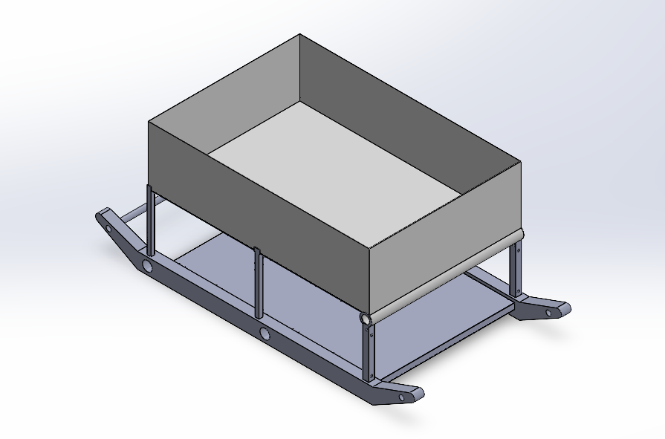
Volume: 0.018 cubic m.
Weight: 48 kg
Price: 15,000/-
The main chassis of the robotic vehicle has to withstand a huge amount of stress caused by the payload therefore the material should be strong enough to hold, the possible materials came out to be Steel, Iron and Aluminium alloys among these Aluminium alloy is the lightest material. So Aluminium alloy 6061 is chosen as the material for chassis.

PVC Foam: Cover Parts, Gears and part of Wheels
Volume: 0.058 cubic m.
Weight: 4.7 kg
Price: 1000/-
The parts that are covering the chassis and some main parts such as the battery and other stuff need to be light in weight and also sustain the forces and stresses acting upon, so the possible materials can be plastic-related items and foams. So PVC foam (80 kg/m3) is chosen.
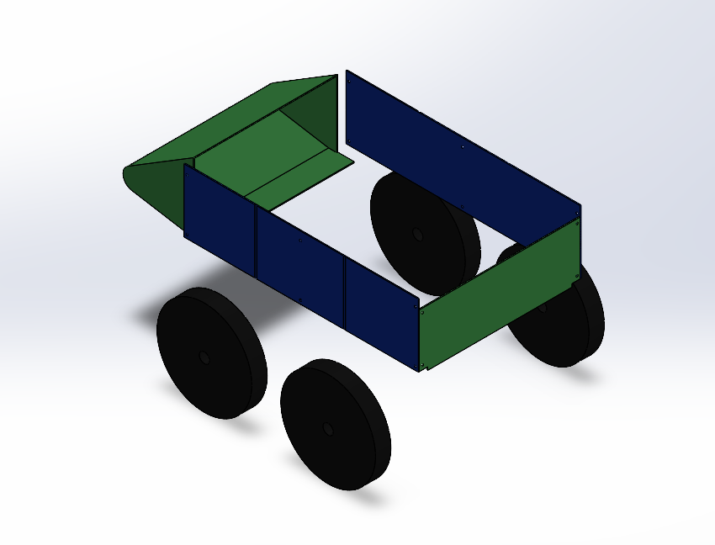

ABS Plastic: Wheels upper layers and Gears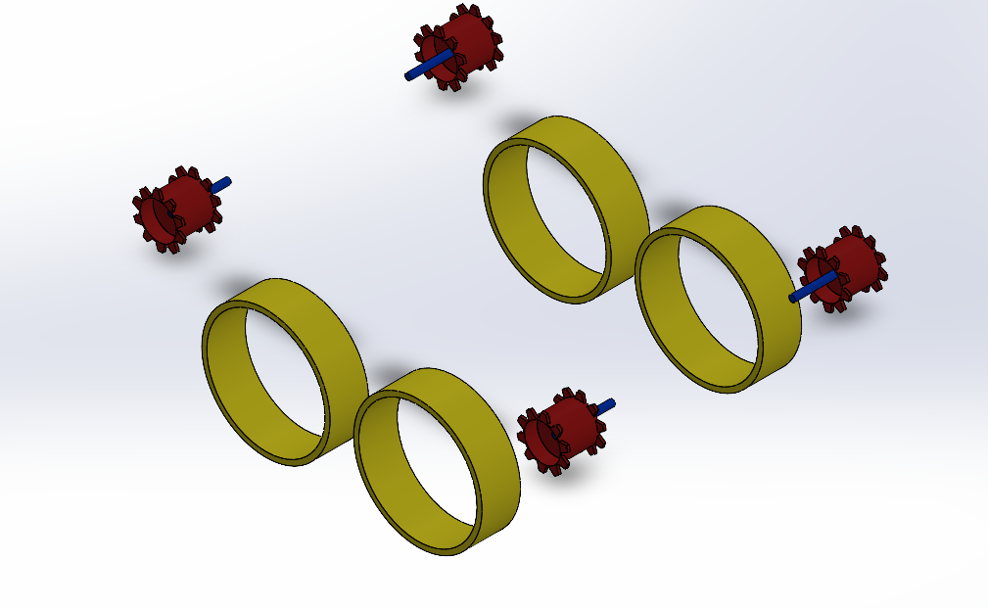
Volume: 0.024 cubic m
Weight: 24 Kg
Total Price: 3,000/-

Belt:
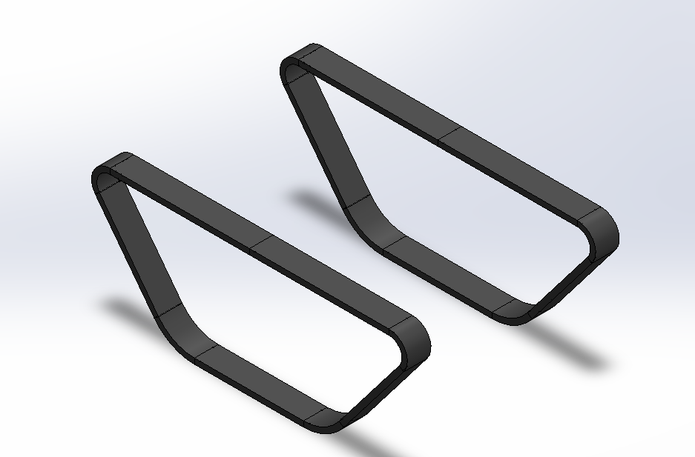
Carbon fibre rods sandwiched between rubber
Total Volume: 0.03 cubic m.
Weight: considering 1100 kg/m3 as density = 33 Kg.
Total Price: Not known. (5000/- approx)

Electrical Stuff:
Motors:
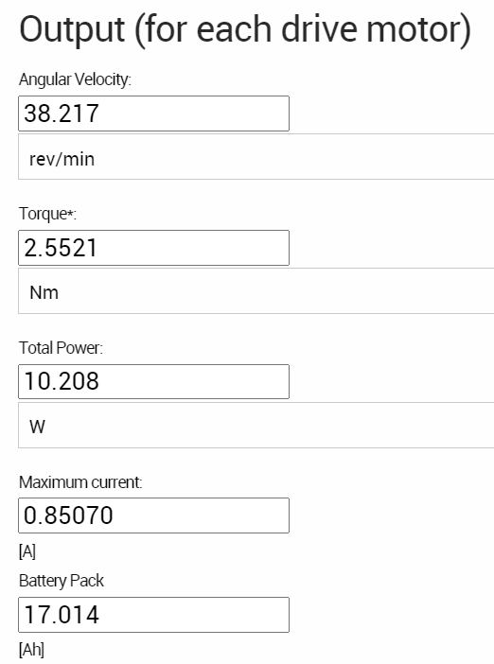
Battery:12 V Li-ion battery of 100 Ah
Link:
Weight:
Price:

Total Price: 40,000/- approx
Total Weight: 150 Kg.

Simulations
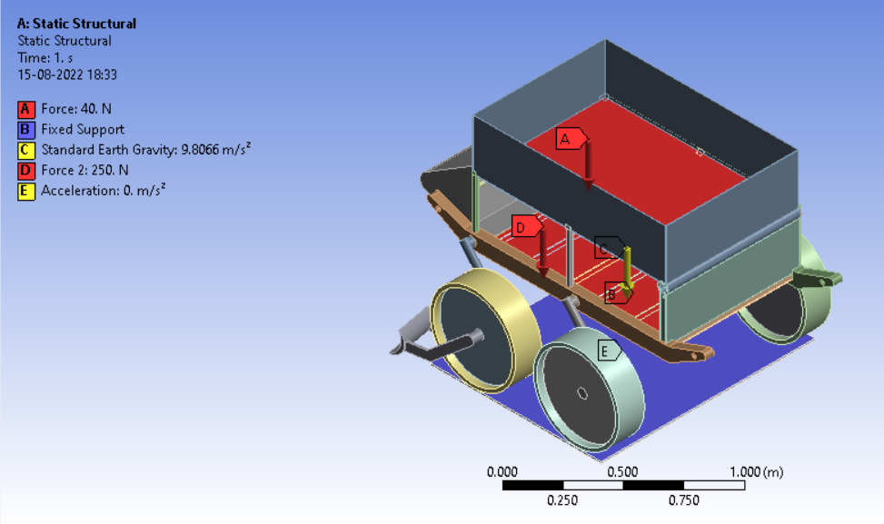
The above forces and accelerations are applied to the design to get stresses and deformations.
For Stress and deformations:
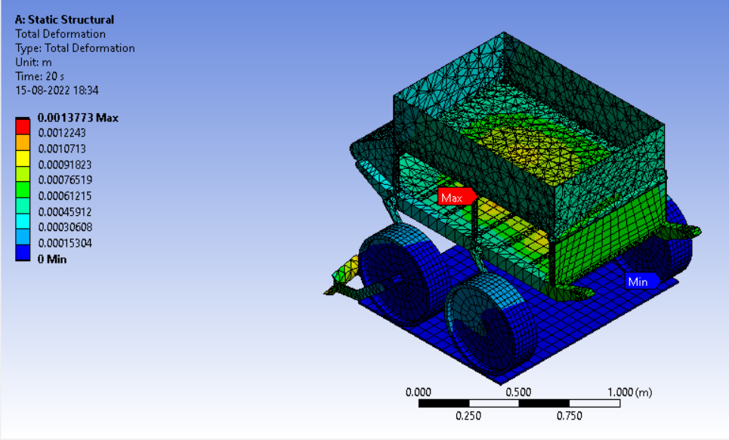
Total Deformation : 0.2 cm
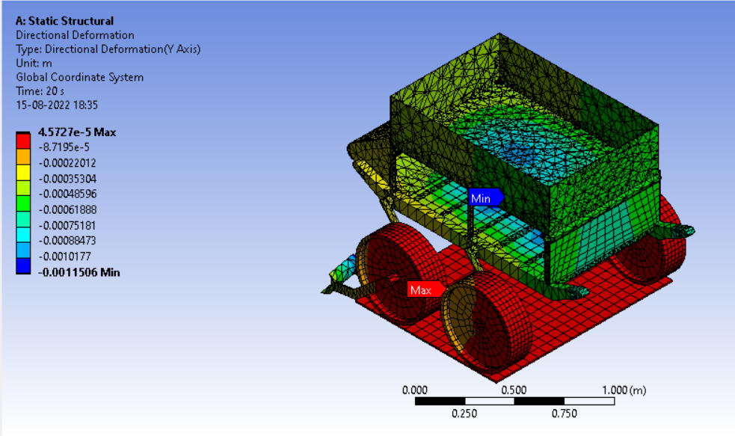
Directional Deformation : 0.12 cm
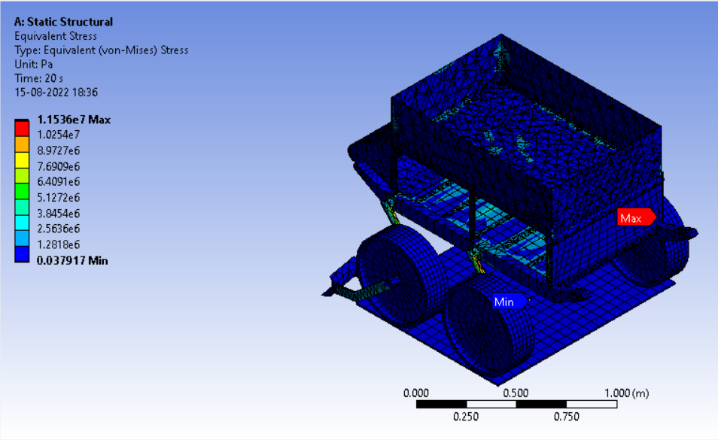
Max Stress: 12 MPa

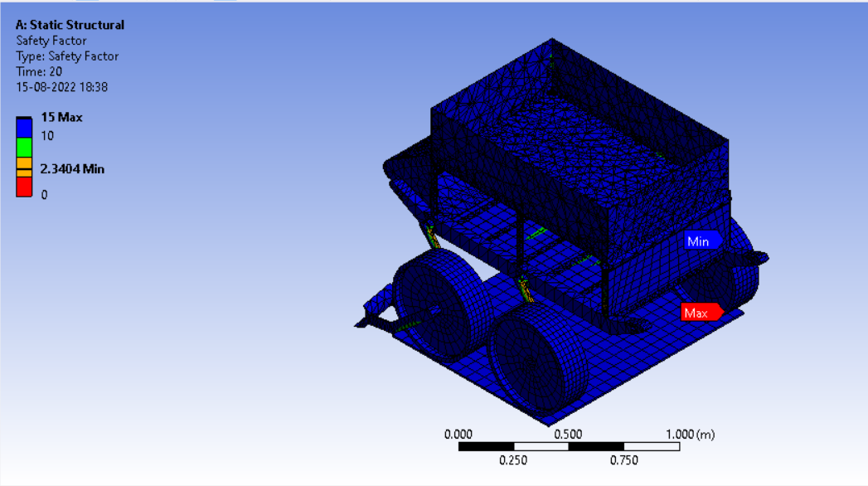
Safety Factor

